**Assignment-4**

**Problem-6:**

Option spreads are strategies that involve the simultaneous purchase and sale of multiple options on the same underlying asset but with different strike prices, expiration dates, or both. Option spreads are very useful as they can be customized based on the market directions expected for the underlying asset. Using option spreads, you can decide exactly how much loss you are willing to risk which is a useful hedging strategy.

**Examples:**

**1) Long Straddle:**

Long Straddle involves buying a call as well as a put option on the same underlying, for the same strike price and expiry. This strategy is used when the underlying is expected to show large movements in either direction or when it is expected that the implied volatility is going to increase.

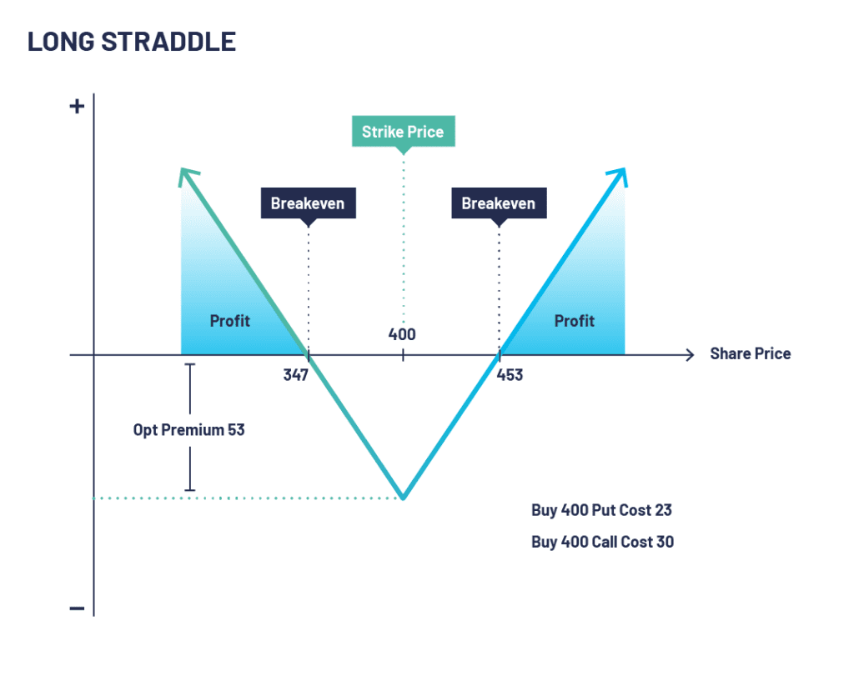

Max Profit: Unlimited

Max Loss: Premium of call option + Premium of put option

Break-even Points: Strike price ± (Premium of call option + Premium of put option)

**2) Short Straddle:**

Short Straddle is essentially the reverse of long straddle. It involves selling a call as well as a put option on the same underlying, for the same strike price and expiry. This strategy is used when the underlying is expected to show only small movements in either direction or when it is expected that the implied volatility is going to decrease.

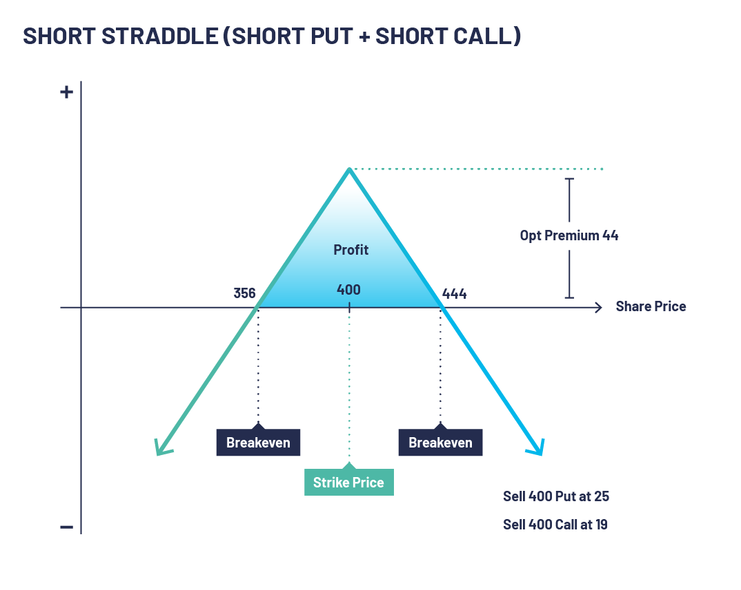

Max Profit = Premium of call option + Premium of put option

Max Loss = Unlimited

Break-even Points: Strike price ± (Premium of call option + Premium of put option)

**3) Long Strangle:**

Long Strangle is a modification of long straddle which further reduces the maximum loss but also decreases the profits. Long Strangle involves buying an OTM Call option and an OTM Put option on the same underlying and expiry. This strategy is used when the underlying is expected to show large movements in either direction or when it is expected that the implied volatility is going to increase.

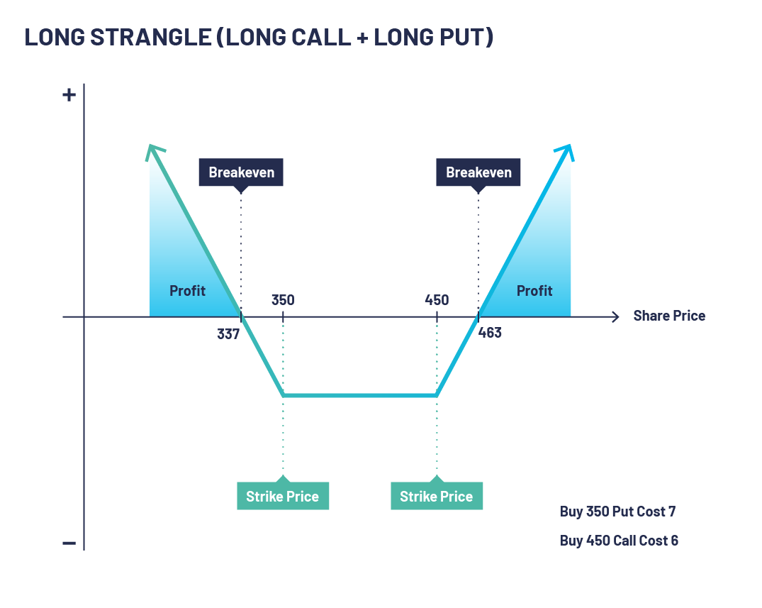

Max Profit: Unlimited

Max Loss: Premium of call option + Premium of put option

Break-even Points: Strike price of put option - (Premium of call option + Premium of put option), Strike price of put option - (Premium of call option + Premium of put option)

**4) Short Strangle:**

Short Strangle is a modification of short straddle which further reduces the maximum profit but widens the range of the underlying for which profit is obtained. Short Strangle involves selling an OTM Call option and an OTM Put option on the same underlying and expiry. This strategy is used when the underlying is expected to show only small movements in either direction or when it is expected that the implied volatility is going to decrease.

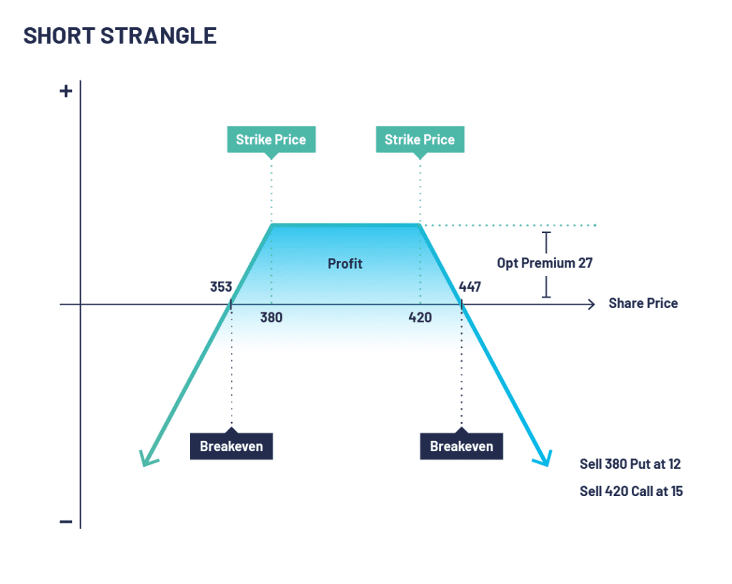

Max Profit: Premium of call option + Premium of put option

Max Loss: Unlimited

Break-even Points: Strike price of put option - (Premium of call option + Premium of put option), Strike price of put option - (Premium of call option + Premium of put option)

**5) Bull Call Spread:**

Bull call spread is used when the investor is moderately bullish on the underlying. It involves buying an ITM Call option and selling an OTM Call option of the same underlying and expiry. This strategy limits both the profit and loss.

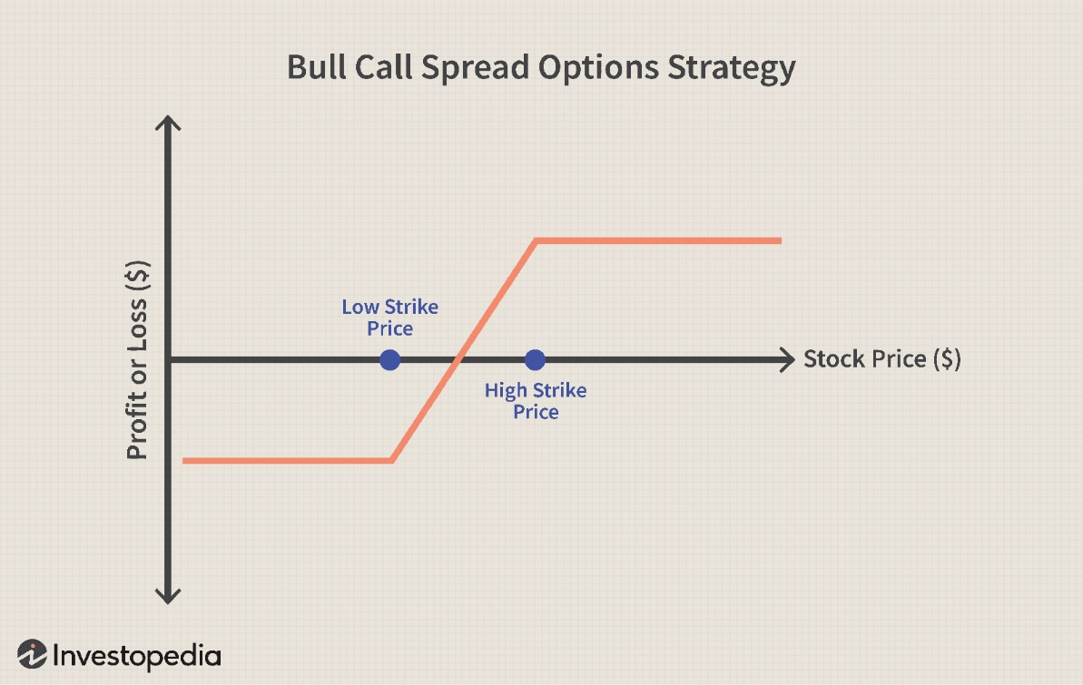

Max Profit: (Strike price of OTM call – Strike price of ITM call) – (Premium of ITM call – Premium of OTM call)

Max Loss: Premium of ITM call – Premium of OTM call

Break-even Point: Strike price of ITM call + (Premium of ITM call – Premium of OTM call)

Similarly, Bear Call Spread can be made where the OTM call option is bought and the ITM call option is sold.

**6) Bear Put Spread:**

Bear put spread is used when the investor is moderately bearish on the underlying. It involves buying an ITM Put option and selling an OTM Put option of the same underlying and expiry. This strategy limits both the profit and loss.

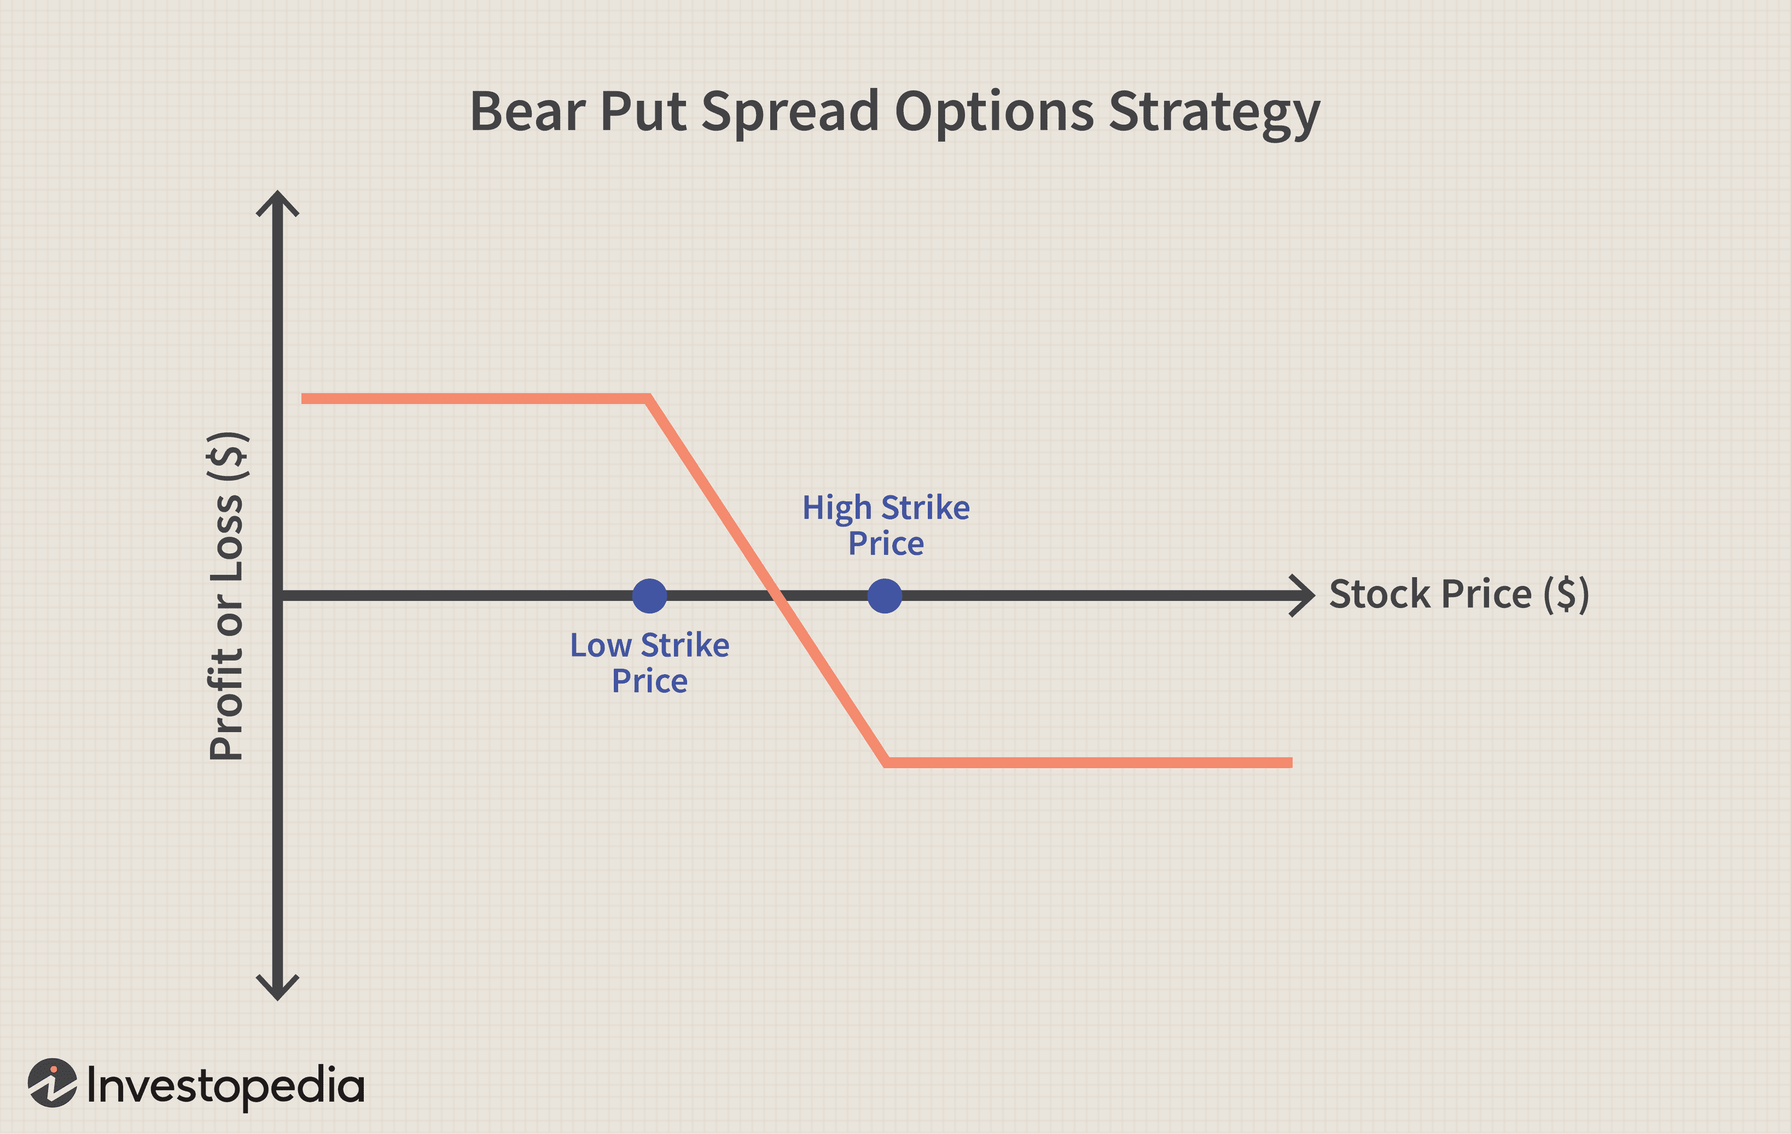

Max Profit: Premium of ITM put – Premium of OTM put

Max Loss: (Strike price of OTM put – Strike price of ITM put) – (Premium of ITM put – Premium of OTM put)

Break-even Point: Strike price of ITM put + (Premium of ITM put – Premium of OTM put)

Similarly, Bull Put Spread can be made where the OTM put option is bought and the ITM put option is sold.